The driving question for 4th grade Science;    
  
There is an empty space available at Vancouver Zoo.  They have not chosen what new species will inhabit this space.  As a scientist, what newly invented creature will you develop to live in that new exhibit area of the zoo?  
  
*For the writing piece; students must write a proposal (a persuasive story) of all the details of its required habitat, shelter, body covering, food/water source, climate control, etc. The proposal must try to convince the zoo committee to adopt their creature for the zoo.  
  
*For the technology piece; students will use at least two websites to research the two animals they are combining to invent this new creature (At least one book must be used for research as well as the internet).   
Students will also use Microsoft Word to type their written piece for the committee to review.

*For the actual creature and its habitat, along with showing its physical adaptations required to survive, they will be required to build a 3-dimensional presentation.

*Both the 3-dimensional habitat and the written piece will be presented in front of the class. Students can complete a live presentation or create a video to demonstrate their learning.

[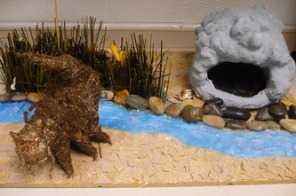](http://mchristiansen.weebly.com/uploads/3/5/8/0/3580120/8657351_orig.jpg)

[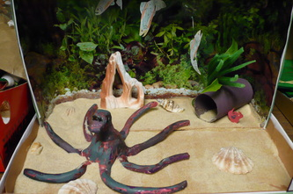](http://mchristiansen.weebly.com/uploads/3/5/8/0/3580120/9568074_orig.jpg)

[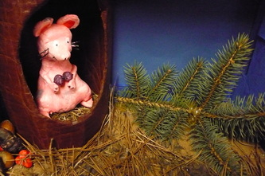](http://mchristiansen.weebly.com/uploads/3/5/8/0/3580120/4495507_orig.jpg)

[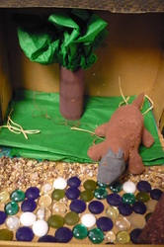](http://mchristiansen.weebly.com/uploads/3/5/8/0/3580120/5281727_orig.jpg)

[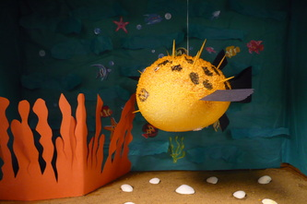](http://mchristiansen.weebly.com/uploads/3/5/8/0/3580120/586893_orig.jpg)

[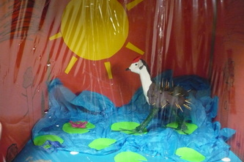](http://mchristiansen.weebly.com/uploads/3/5/8/0/3580120/2939666_orig.jpg)

[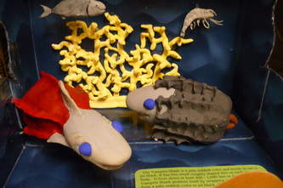](http://mchristiansen.weebly.com/uploads/3/5/8/0/3580120/7794008_orig.jpg)

[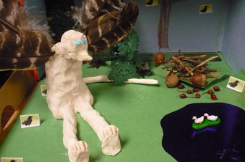](http://mchristiansen.weebly.com/uploads/3/5/8/0/3580120/6574443_orig.jpg)

[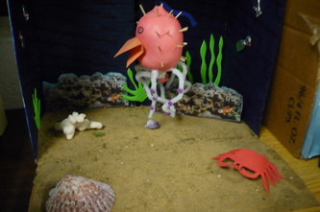](http://mchristiansen.weebly.com/uploads/3/5/8/0/3580120/3957466_orig.jpg)

[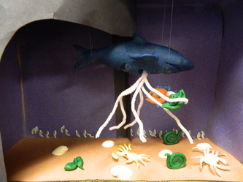](http://mchristiansen.weebly.com/uploads/3/5/8/0/3580120/69038_orig.jpg)

[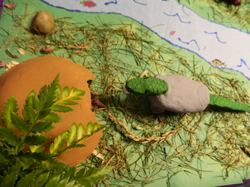](http://mchristiansen.weebly.com/uploads/3/5/8/0/3580120/2199627_orig.jpg)

[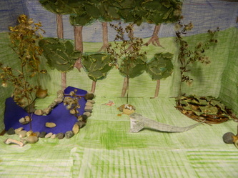](http://mchristiansen.weebly.com/uploads/3/5/8/0/3580120/7116_orig.jpg)

[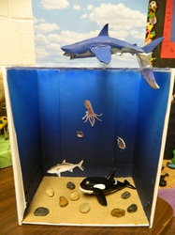](http://mchristiansen.weebly.com/uploads/3/5/8/0/3580120/2423530_orig.jpg)

[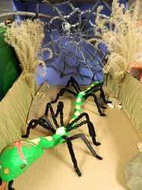](http://mchristiansen.weebly.com/uploads/3/5/8/0/3580120/2355258_orig.jpg)

[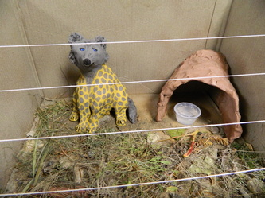](http://mchristiansen.weebly.com/uploads/3/5/8/0/3580120/8258112_orig.jpg)

[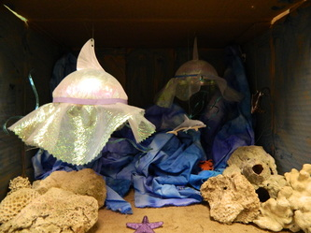](http://mchristiansen.weebly.com/uploads/3/5/8/0/3580120/5173490_orig.jpg)

[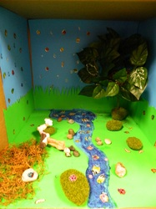](http://mchristiansen.weebly.com/uploads/3/5/8/0/3580120/2683279_orig.jpg)

[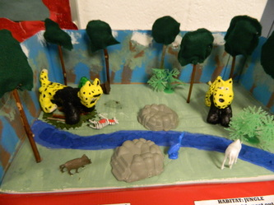](http://mchristiansen.weebly.com/uploads/3/5/8/0/3580120/6109983_orig.jpg)

[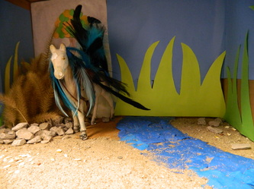](http://mchristiansen.weebly.com/uploads/3/5/8/0/3580120/3906792_orig.jpg)

[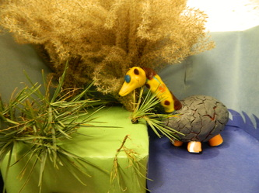](http://mchristiansen.weebly.com/uploads/3/5/8/0/3580120/99251_orig.jpg)

[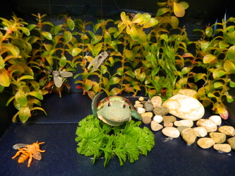](http://mchristiansen.weebly.com/uploads/3/5/8/0/3580120/5175393_orig.jpg)

[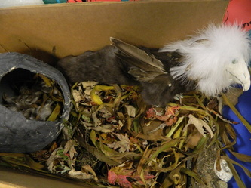](http://mchristiansen.weebly.com/uploads/3/5/8/0/3580120/2162110_orig.jpg)

[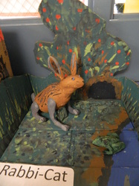](http://mchristiansen.weebly.com/uploads/3/5/8/0/3580120/8343127_orig.jpg)

[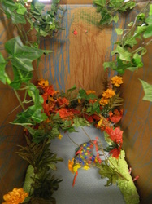](http://mchristiansen.weebly.com/uploads/3/5/8/0/3580120/8650165_orig.jpg)

[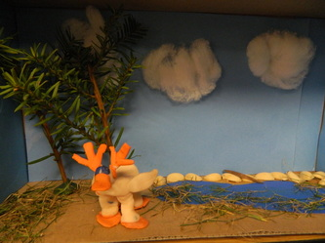](http://mchristiansen.weebly.com/uploads/3/5/8/0/3580120/5886171_orig.jpg)

[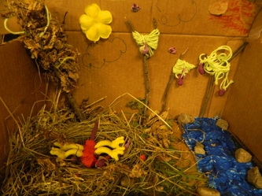](http://mchristiansen.weebly.com/uploads/3/5/8/0/3580120/6045913_orig.jpg)

[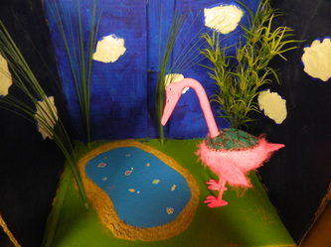](http://mchristiansen.weebly.com/uploads/3/5/8/0/3580120/1075335_orig.jpg)

[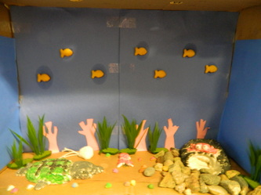](http://mchristiansen.weebly.com/uploads/3/5/8/0/3580120/3431954_orig.jpg)

[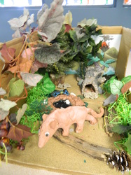](http://mchristiansen.weebly.com/uploads/3/5/8/0/3580120/2765291_orig.jpg)

[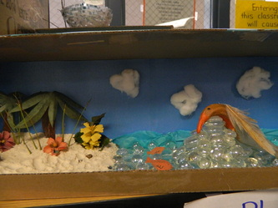](http://mchristiansen.weebly.com/uploads/3/5/8/0/3580120/487975_orig.jpg)